**A PROJECT REPORT ON**

**WEBSITE TITLED “MOODY FOODY”**

(Submitted on fulfillment of the requirement of the Certified course in Web Designing)



**NATIONAL INSTITUTE OF ELECTRONIC AND INFORMATION TECHNOLOGY**

**Submitted To : Submitted By :**

**Ms. Rishbha Yadav Shikha Jha [Reg. no. -1302831]**

**Assistant Faculty Himanshi Gupta [Reg. no. -1302823]**

**Parveena Khatun [Reg. no. -1302825]**

**DECLARATION**

We hereby declare that the work done on the website titled “Moody Foody” has been carried out by Parveena khatun , Shikha Jha and Himanshi Gupta as a team project and submitted in the fulfillment of the requirement for the “Certified Course in Web Designing” at Nielit, New Delhi.

Name : Himanshi Gupta ( Rollno :- 2)

Praveena Khatun ( Rollno :- 13)

Shikha Jha ( Rollno :- 8)

Date : 28 November 2019

Course :- Certified Course in Web Designing(WD009)

**ACKNOWLEDGEMENT**

The satisfaction that accompanies the successful completion of our project would be incomplete without the mention of people whose cooperation made it possible, whose constant guidance and encouragement crown all efforts with success. We are grateful to our project mentor Ms. Rishbha Yadav for her guidance, inspiration and constructive suggestions that helped us in preparation of the project. We would like to extend our heartfelt gratitude to our parents and friends whose constant support helped us to emerge with a successful project.

**TABLE OF CONTENTS**

|  |  |  |
| --- | --- | --- |
| **S. No.** | **TOPIC** | **PAGE NO.** |
| 1. | DECLARATION |  |
| 2. | ACKNOWLEDGEMENT |  |
| 3. | AIM OF THE  PROJECT |  |
| 4. | TOOLS AND TECHNOLOGIES USED |  |
| 5. | WEBSITE-  MOODY FOODY |  |
| 6. | CH – 1 HOME PAGE   * 1. NAVIGATION BAR   2. GALLERY   3. FEEDS   4. FOOTER   5. POPUP CHAT WINDOW |  |
| 7. | CH – 2 ABOUT US |  |
| 8. | CH -3 MENU  3.1. HEADER  3.2. SLIDESHOW GALLERY |  |
| 9. | CH – 4 CONTACT US |  |
| 10. | CH – 5 LOGIN |  |
| 11. | CH – 6 SIGN UP |  |
| 12. | SOURCE CODE OF THE PROJECT |  |
| 13. | CONCLUSION AND FUTURE SCOPE |  |
| 14. | REFERENCES |  |

**AIM OF THE PROJECT**

Aim of our project is to create a food website by using HTML , CSS, JavaScript and photoshop. The title of our website is “MOODY FOODY” . The purpose of our website is to promote dining through user friendly environment and providing food at comparable rates..

**TOOLS AND TECHNOLOGIES USED**

1. HTML
2. CSS
3. JavaScript
4. Photoshop
5. Notepad
6. Sublime text 3
7. Web Browser( e.g – Google Chrome)

**THE WEBSITE – MOODY FOODY**

* The website is built using notepad and sublime. It comprises of 6 webpages interlinked together.
* Basic structure of website is made through html <div> tag.
* The styling of website is done through CSS(Internal, external and Inline).
* JavaScript is being added to forms , popup chat window ,to add navigation bar on scroll and to display menu through gallery.
* Photoshop is used to make gif , menu cards and background page/header.
* We have embedded facebook and twitter feeds of public accounts.
* A popup chat window feature is added to solve user queries.
* Data validation is implemented in forms.
* Data object and event handlers (javascript) is used .

**CH - 1**

**HOME PAGE (home.html)**

* In the home page, we have following elements:-
  1. Navigation bar
  2. Gif(created by photoshop)
  3. Gallery
  4. Feeds( Facebook, Instagram, Twitter)
  5. Footer
  6. Popup Chat Window
* The user can navigate to other pages through Navigation bar and links given in footer.
* For making user’s visit to our website user easy and comfortable, we have created a pop up window to chat with the user.

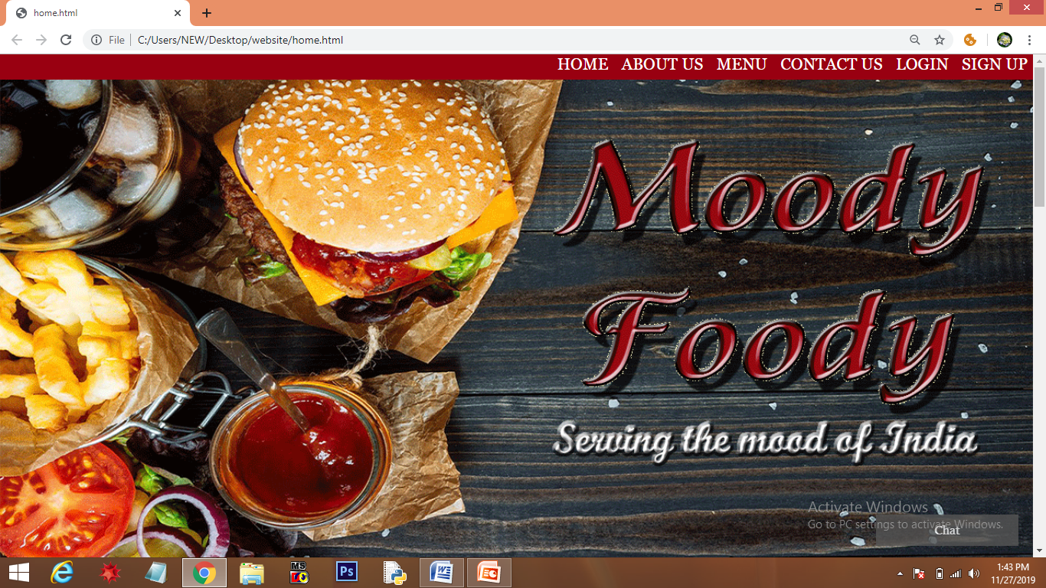

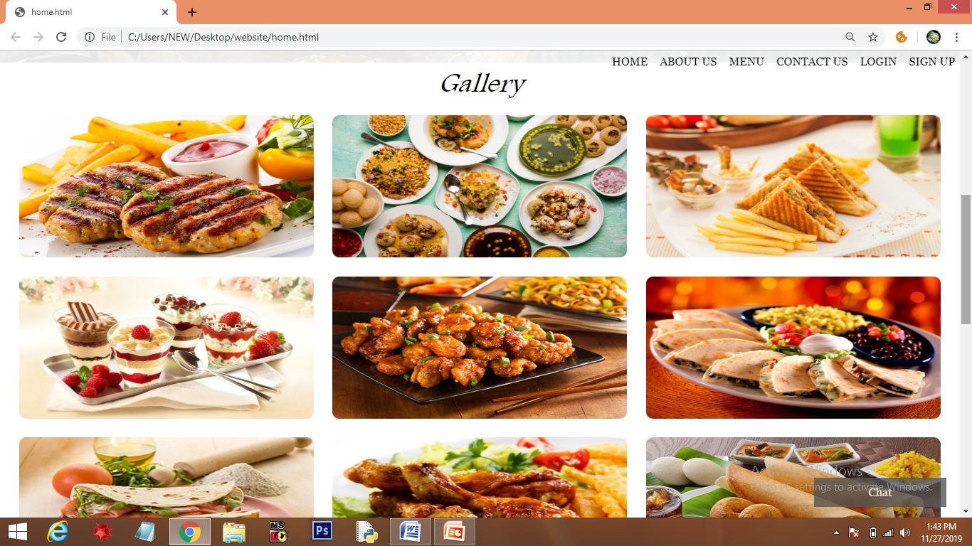

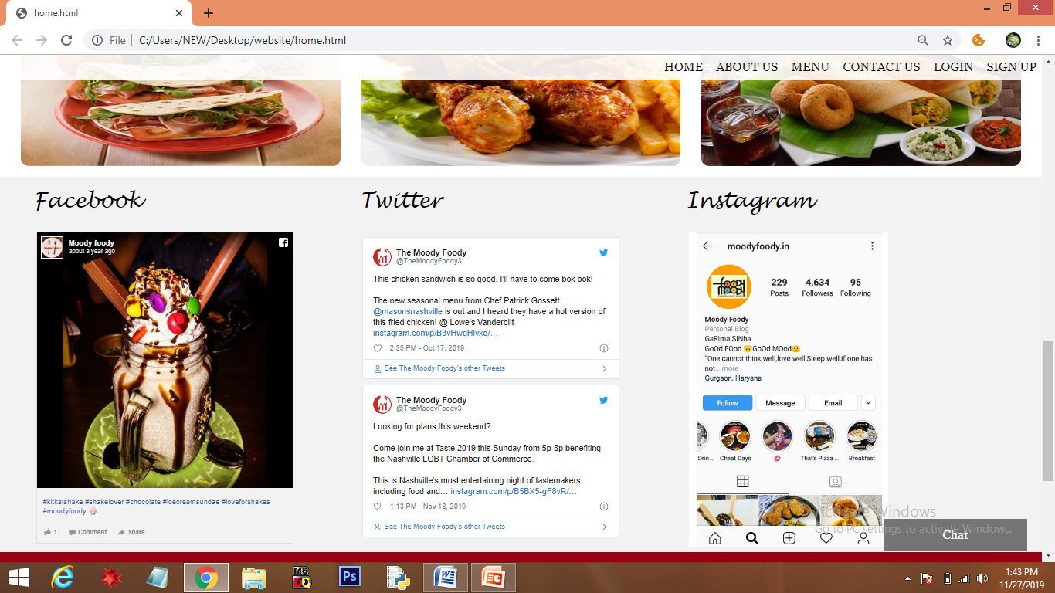

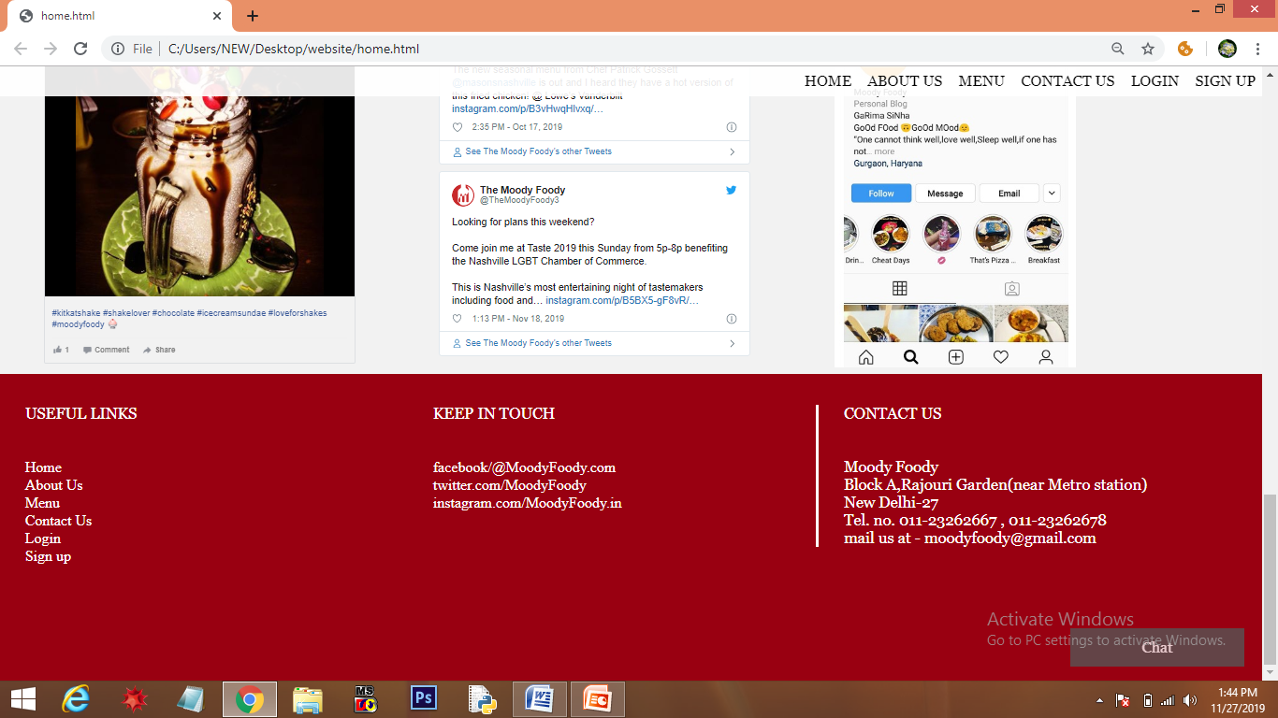

* 1. NAVIGATION BAR
* Navigation bar contains links to all 6 webpages of website including homepage.
* When the user hover over any of the link color changes from black to green and background color changes from red to white. This styling is done through CSS.

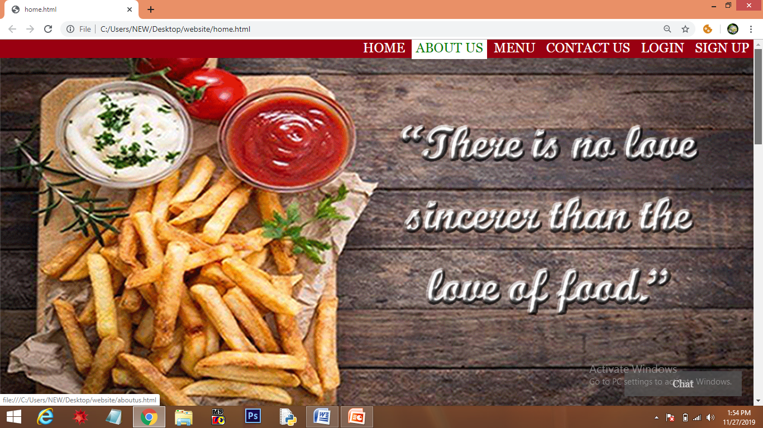

* When the user clicks on any of the link, that webpage is opened in the same tab.

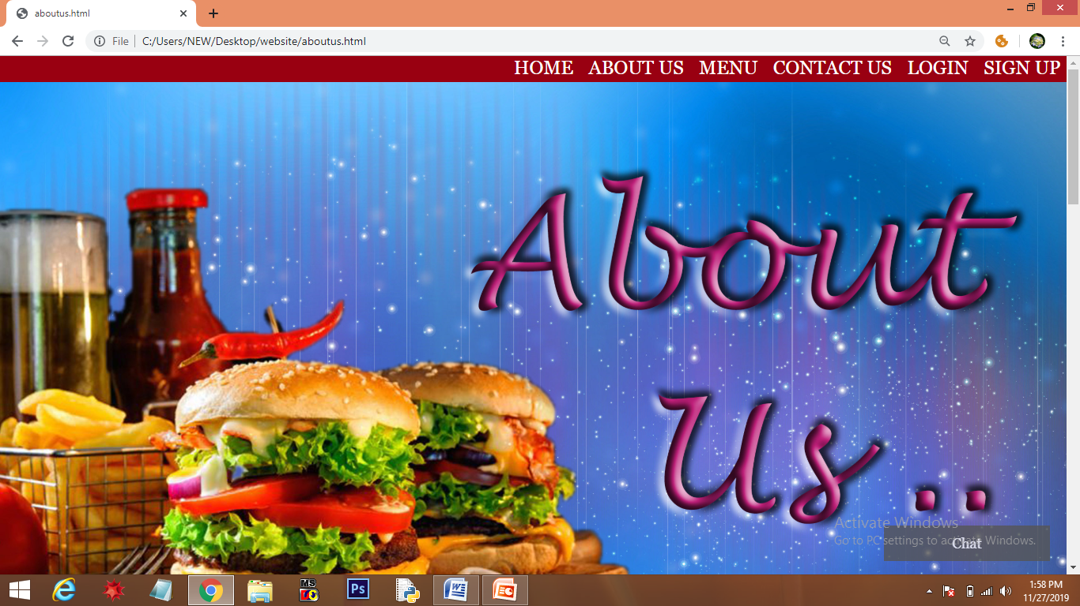

* As the user scrolls the webpage, a menu bar appears with a opacity 0.9 and on hover color changes to green and background to white(applied through CSS).

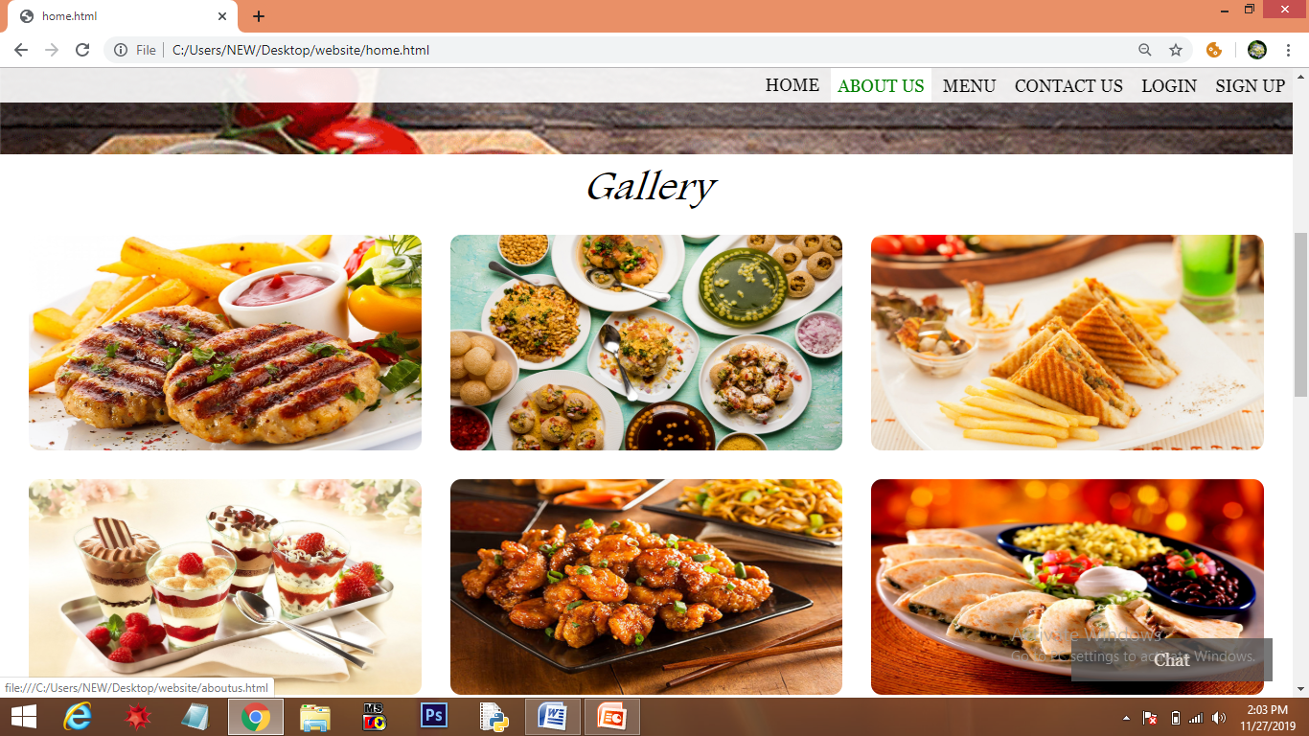

* 1. **GALLERY**
* Gallery contains images of the food in 3 columns and 3 rows. This structure is created through nested <div> tag.
* Each column is given 33.33% width so that they occupy same width.
* Border radius property in CSS is used to give round corners to the images.

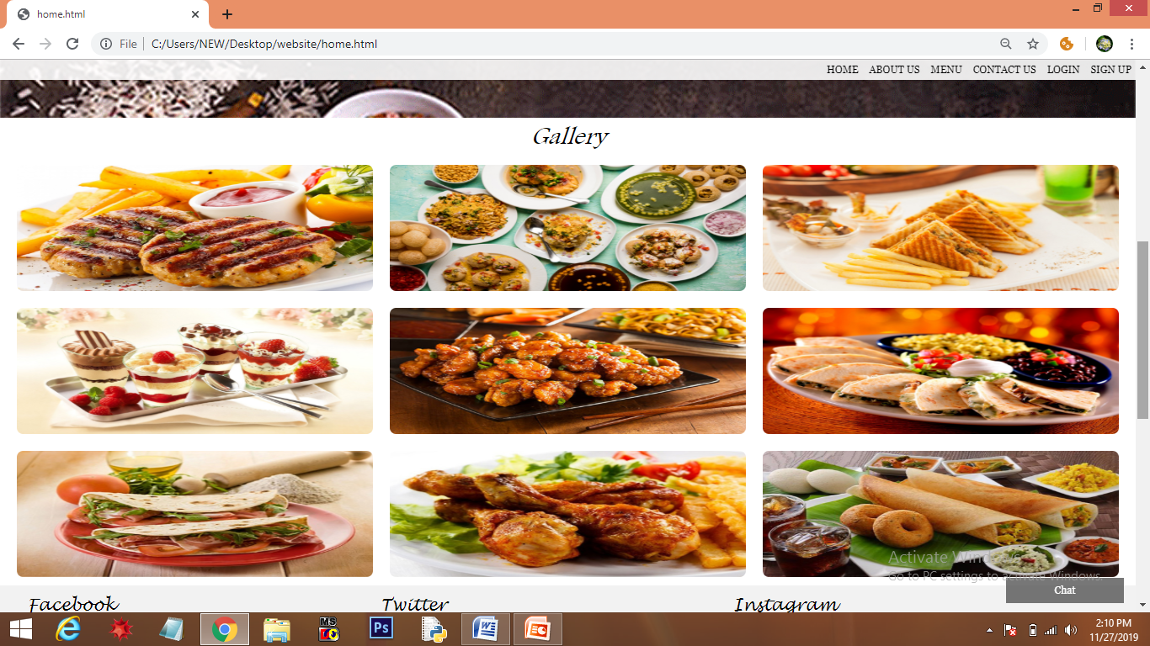

* 1. **FEEDS**
* Feeds of Facebook and Twitter is added through embed option . Instagram page is a image that is added through <img> tag.
* When user click over the feed/image, particular page is opened in new tab.
* The structure is created through nested <div> tag and styled by CSS.

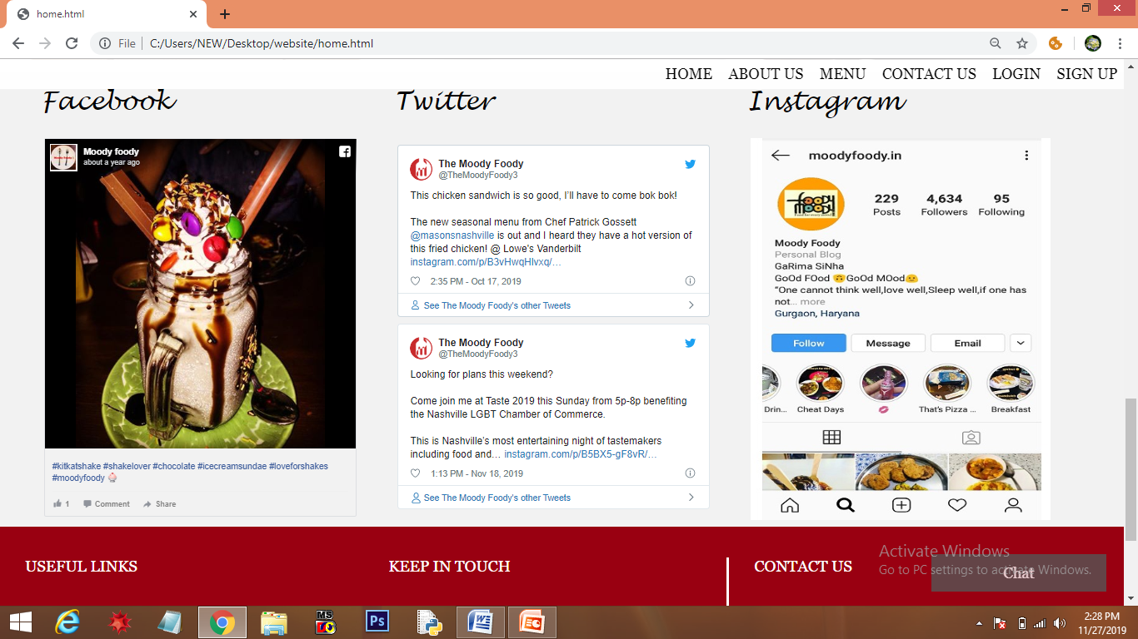

* 1. **FOOTER**
* Footer is divided into 3 sections using <div> tag.

1. “USEFUL LINKS” – It contains all the links to the various pages of the website.

2. “KEEP IN TOUCH” - It contain links to the social platforms(facebook, instagram and twitter).

3. It contains the address , Contact no. and Email Id of Moody Foody.

* The first two sections contains links , so when we hover over it , color changes to yellow(through CSS).

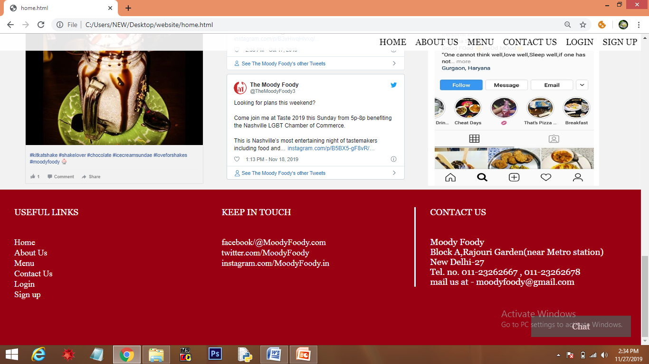

* 1. **POPUP CHAT WINDOW**
* At the bottom of every page, there is a chat icon, on clicking the chat button ,a chat window will open .The user can ask his/her queries through it.
* If the user want to send the query , he/she should click the ‘Send’ button and if user wants to close the Chat window, he/she should click the ‘Close’ button.

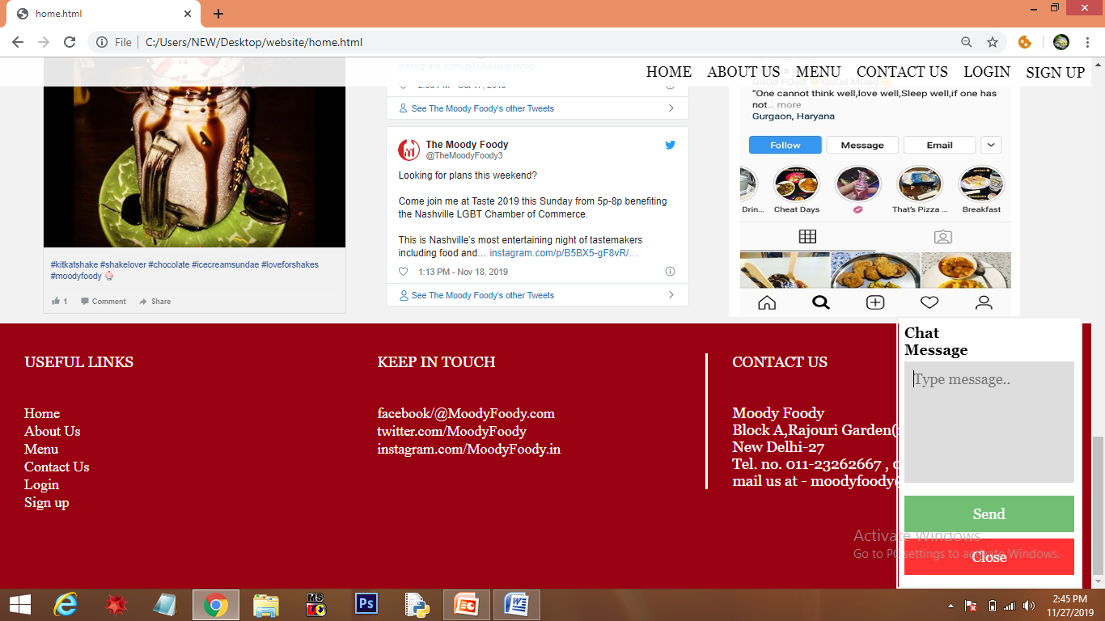

**CH – 2**

**ABOUT US (aboutus.html)**

* You can navigate to “About Us” either through navigation bar or link in footer.
* About Us page have 3 sections:
  1. Image (created through photoshop).
  2. About the concept “moody Foody”.
  3. Images of Team members with their details (through nested <div> tag).

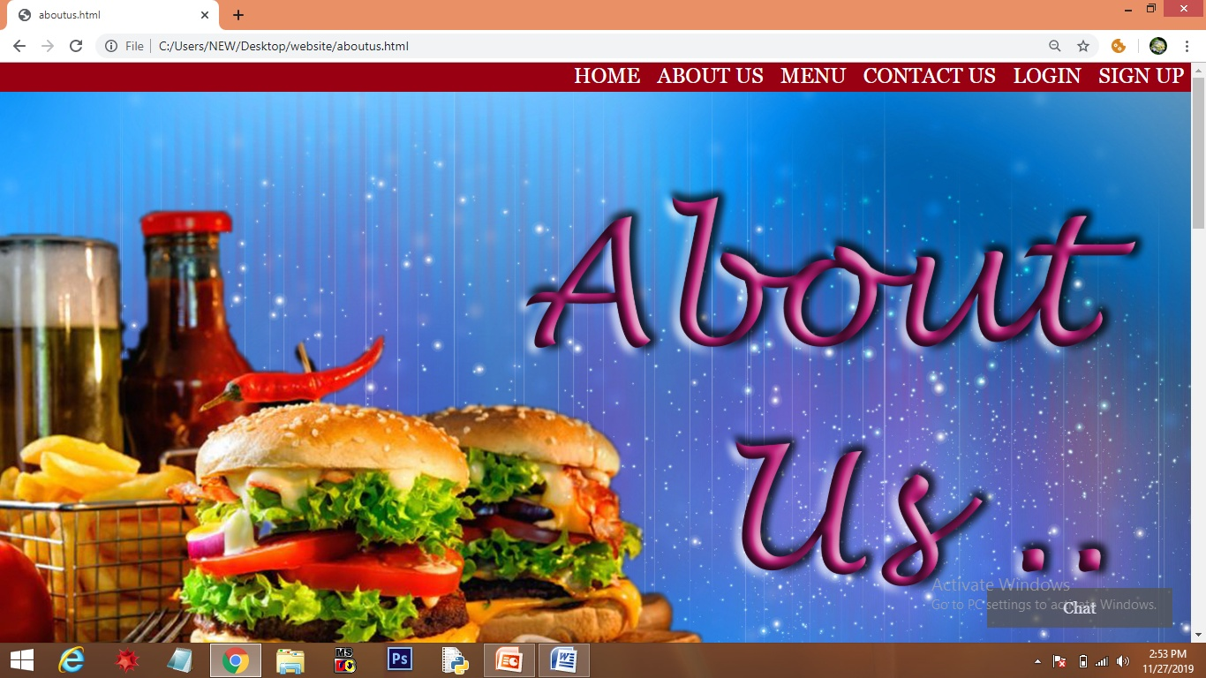

* Image

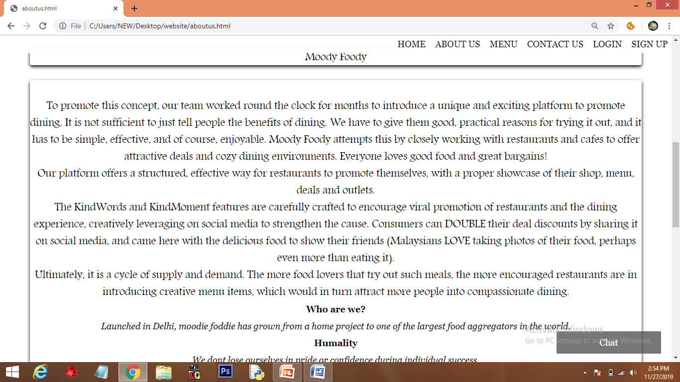

* About the concept “MOODY FOODY”.

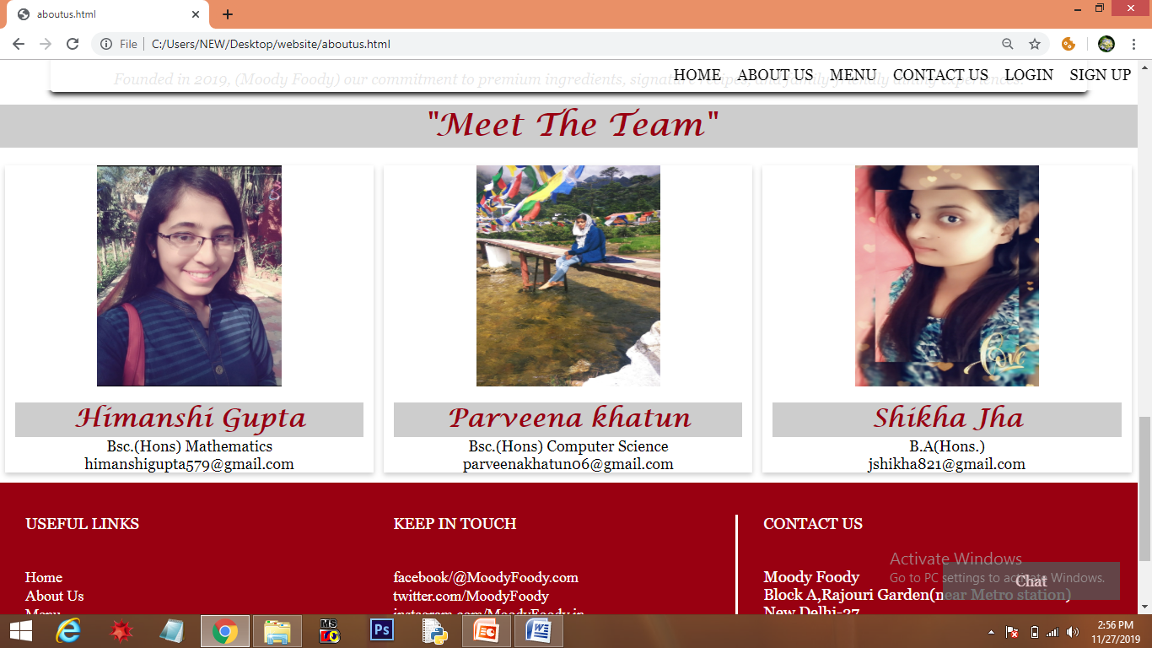

* Team Members.

CH – 3

MENU (menu.html)

* We can navigate to menu either through navigation bar or through links given in the footer.
* Menu have 2 sections:-

1. Header.
2. Slideshow Gallery.
   1. **HEADER**

* Header is created through photoshop and placed through <div> tag.

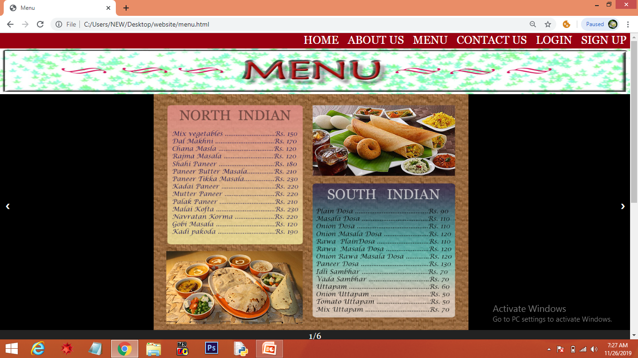

* 1. SLIDESHOW GALLERY
* Each menu is created through tools in photoshop.
* The slide gallery is created through JavaScript and it’s styling is done by css and alignment through html <div> tag.
* To slide the menus’ the user can either use buttons on left and right side or through a gallery created just below it.
* If the user clicks on the 3rd menu , then 3rd menu will be displayed in slideshow from gallery.
* By default, when page is loaded, first menu page is opened in slideshow.

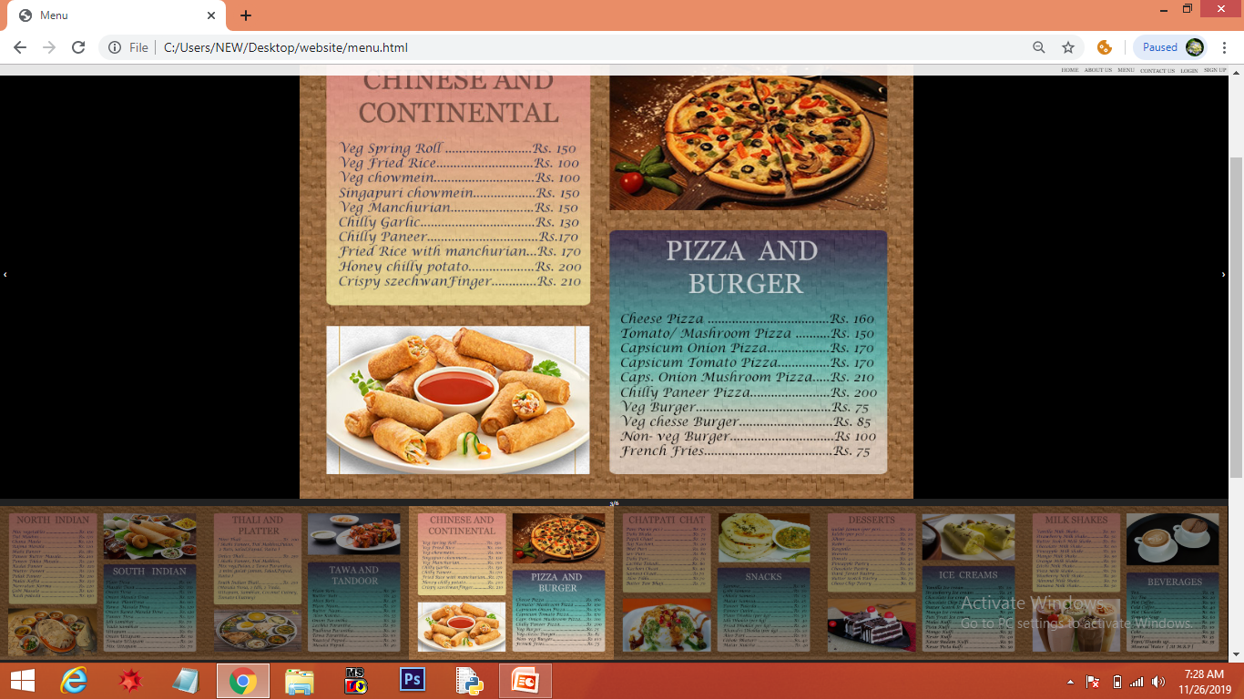

**CH – 4**

**CONTACT US ( contactus.html)**

* The user can give his/her suggestions and feedback through the Contact Form.
* The form is user friendly as it contains minimum fields .
* Fields in form:-

First Name, Last Name, City, suggestions.

* After entering the data in the contact form , the user can click the send button or link . As soon as link is clicked, email will sent.

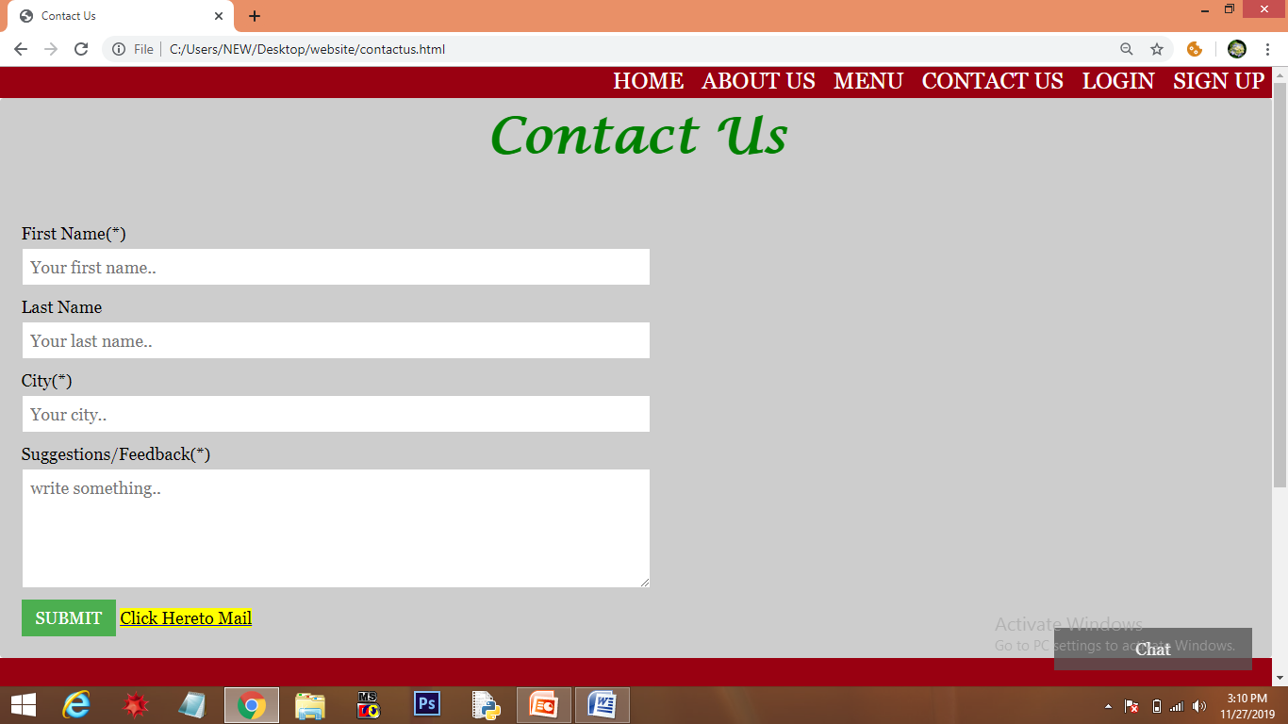

* Validation is being added to the form. Till the user enter all the necessary details, he/she cannot submit the form.

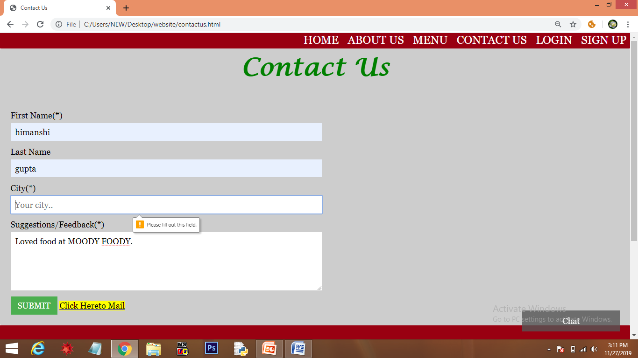

* JavaScript event handler is added to the form. When the user submit the form, JavaScript function is called through ‘onclick’ (event handler) which alerts a message that “Your form has been submitted”.

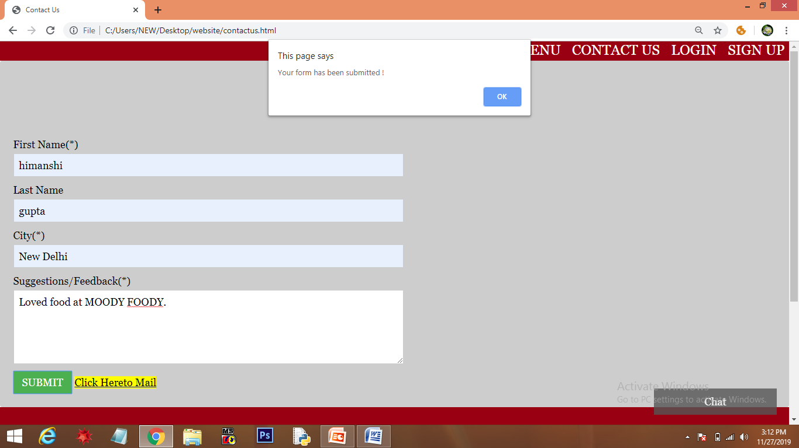

**CH – 5**

**LOGIN (login.html)**

* The existing users can login through ‘LOGIN’ in navigation bar or through link in the footer.
* The user requires a ‘user name’ and ‘password’ to login .

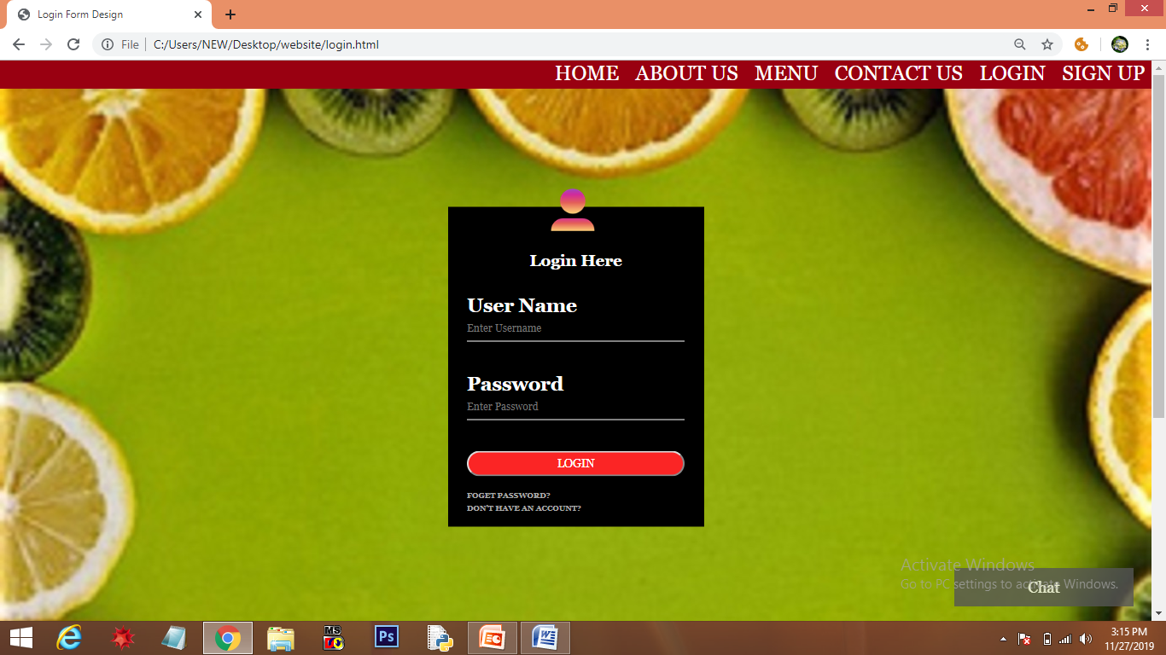

* Data Validation is been added to the form. Both ‘User name’ and ‘password’ are necessary to login’.
* As the user hover over login button, color changes from red to yellow.(implemented through css)

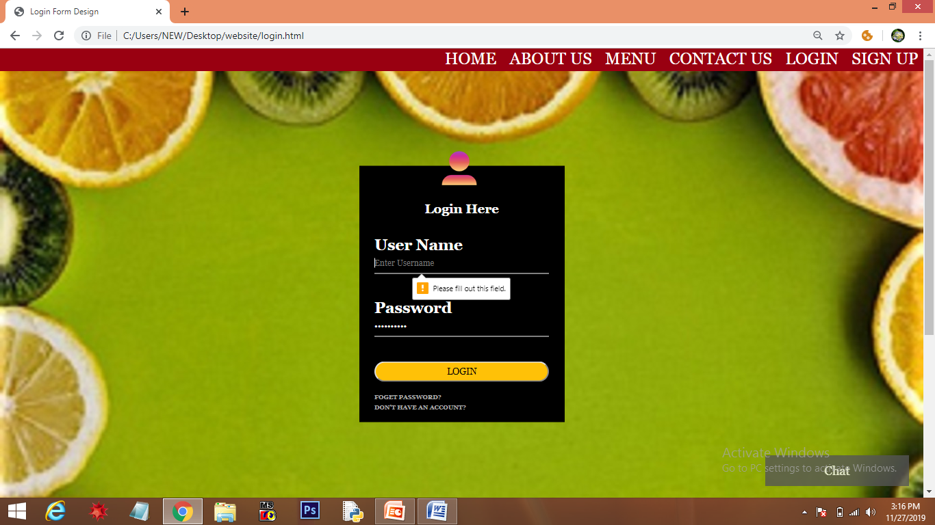

* When the user login, home page is loaded automatically.
* In case the user forgets the password, he/ she can click “FORGET PASSWORD” link.
* When the user clicks on it, a prompt box is displayed asking for new password.

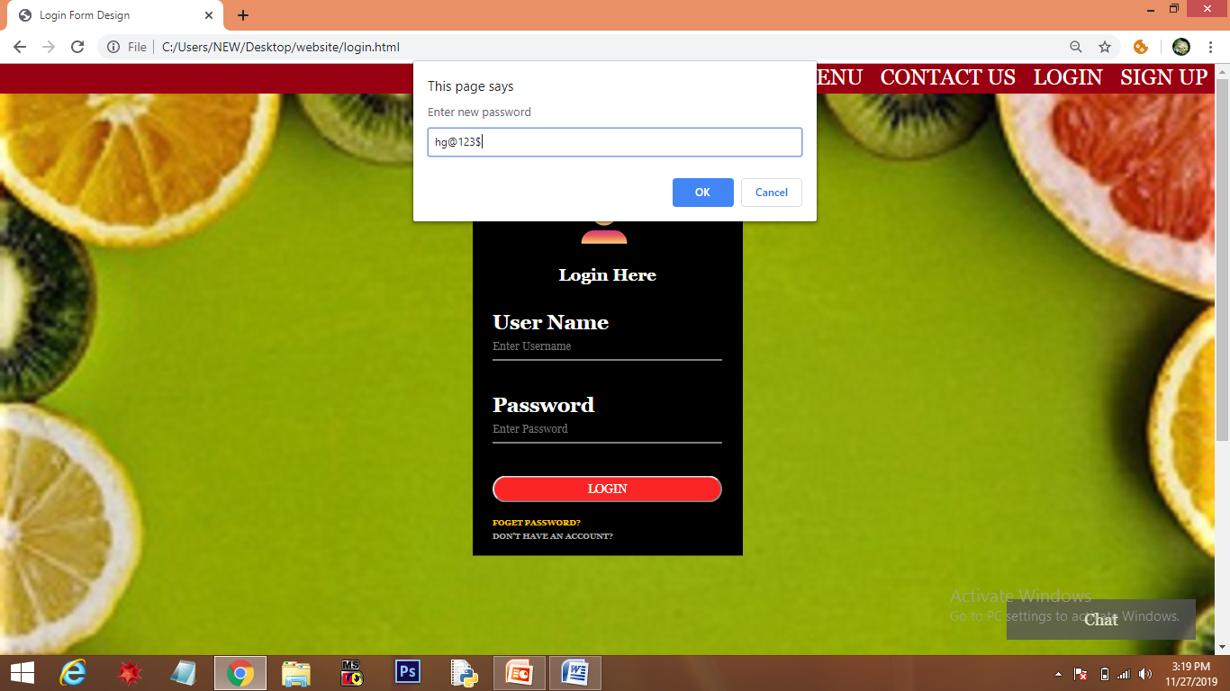

* When the user enters the password and click ‘OK’, an alert is displayed “Your password is changed”.

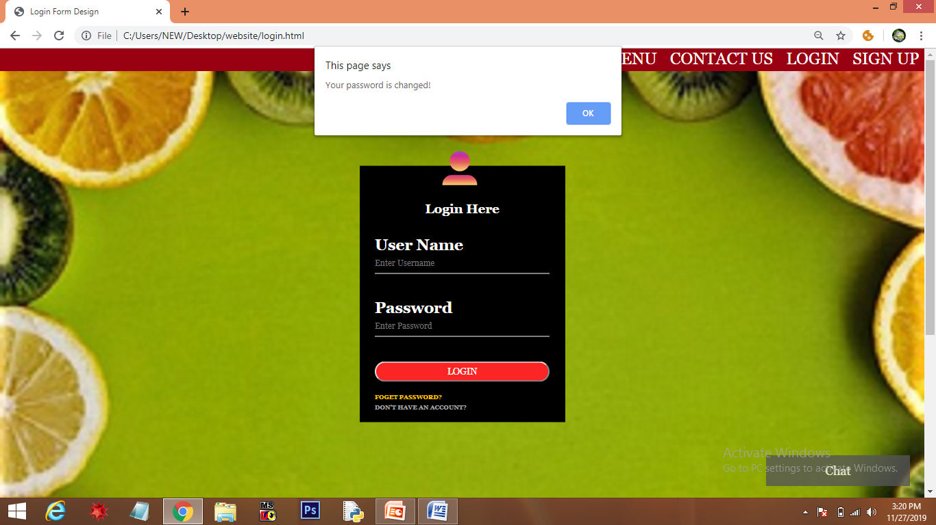

* In case of new user, he/she can click “DON’T HAVE AN ACCOUNT” (As user hover ,color changes from grey to yellow through CSS) .
* As user click on it, signup page is loaded .

**CH – 6**

**SIGN UP (signup.html)**

* If a user wants to open an account, he/ she has to signup either through navigation bar or link in footer.
* Data Validation is added to the form. All the necessary details need to be filled up correctly .

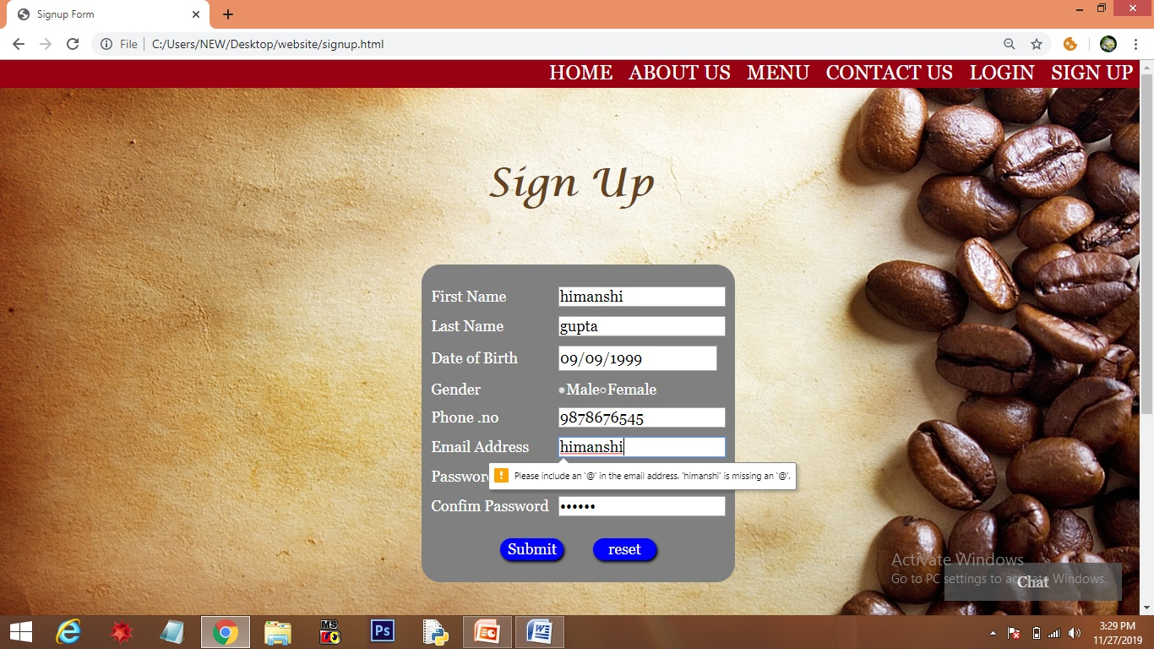

* In case the password didn’t match , an alert message is displayed “Password donot match, Try again…” and on clicking ‘OK’ form is refreshed.

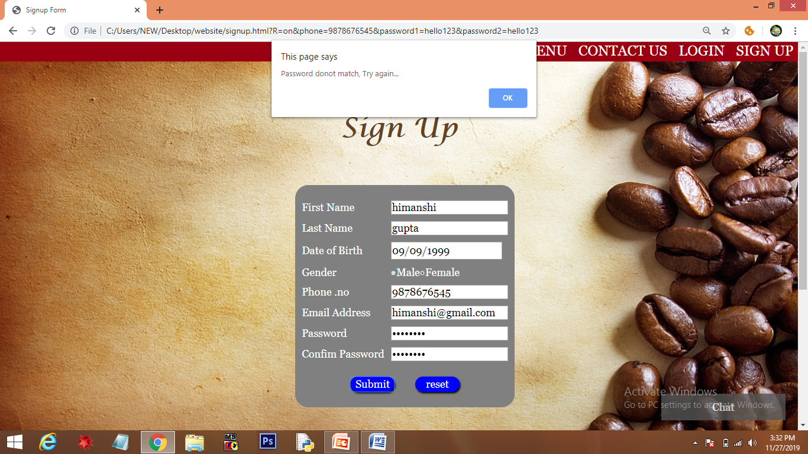

* When all the details are correct and user clicks on ‘submit’ , an alert message is displayed “Signed up successfully”.

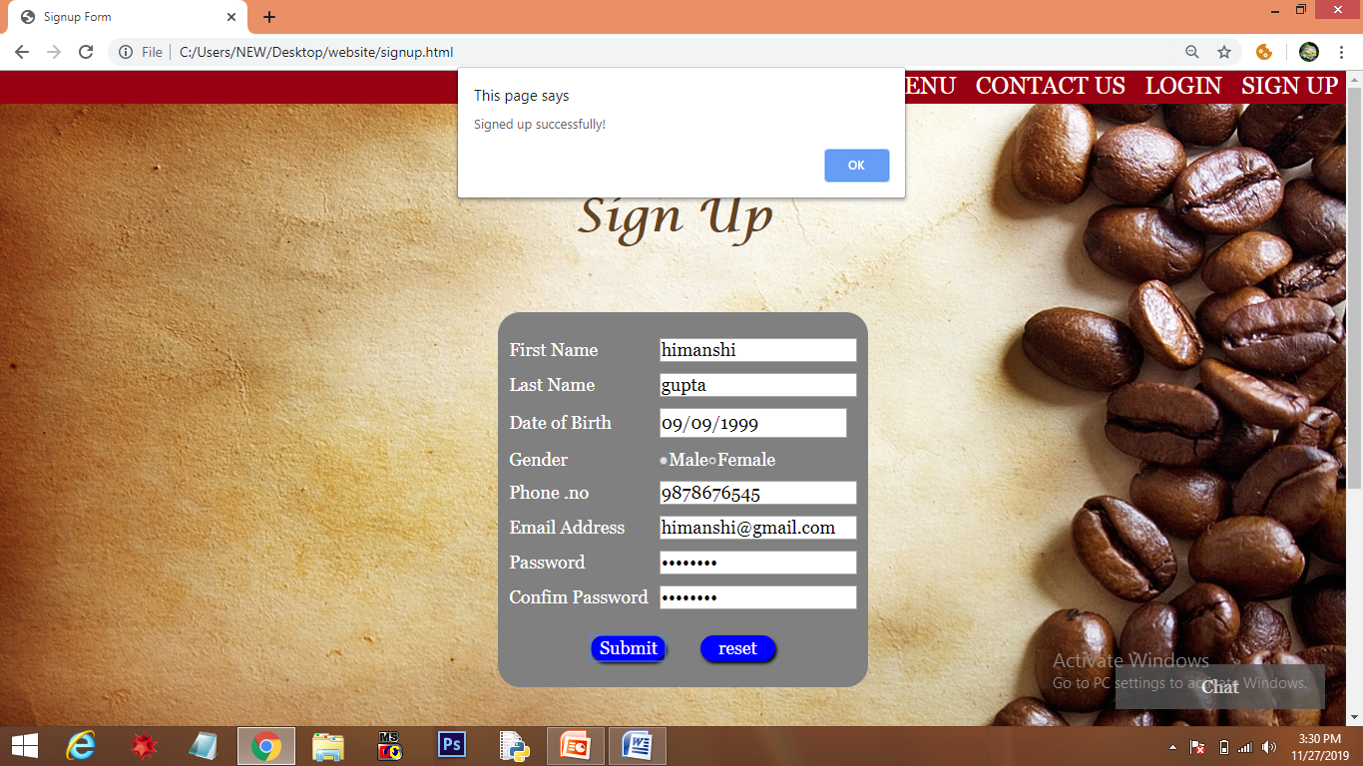

* If user wants to edit form, he/ she can click on ‘reset’ button to refresh the form.

SOURCE

CODE

**HOME (home.html)**

<html>

<head>

<link rel="stylesheet" type="text/css" href="style.css">

<meta name="viewport" content="width=device-width, initial-scale=1">

<script async defer src="https://connect.facebook.net/en_US/sdk.js#xfbml=1&version=v3.2"></script>

<style type="text/css">

* {

box-sizing: border-box;

}

.sliding{

background-image: url(slide.gif);

width: 100%;

height: 100%;

background-attachment: fixed;

background-size: cover;

}

.heading{

text-align: center;

}

.heading span{

color: black;

font-family: Andalus;

font-style: oblique;

font-size: 60px;

}

.gallery::after {

content: "";

clear: both;

display: table;

}

.column:hover {

transform: scale(1.06);

}

.column{

float: left;

width: 33.33%;

padding: 20px;

}

.gallery{

margin-right: 20px;

margin-left: 20px;

}

.gallery img{

height: 300px;

width: 400px;

border-radius: 15px;

}

.social{

background-color: f2f2f2;

}

.social::after {

content: " ";

clear: both;

display: table;

}

.smedia{

float: left;

width: 30.33%;

padding: 10px;

margin-left: 20px;

font-family: "lucida Handwriting";

font-size: 40px;

margin-top: 10px;

}

* {box-sizing: border-box;}

</style>

</head>

<body>

<div class="bar">

<a href="home.html">HOME</a>

<a href="aboutus.html ">ABOUT US</a>

<a href="menu.html">MENU</a>

<a href="contactus.html ">CONTACT US</a>

<a href="login.html ">LOGIN</a>

<a href="signup.html ">SIGN UP</a>

</div>

<div class="navbar" id="navbar">

<a href="home.html ">HOME</a>

<a href="aboutus.html ">ABOUT US</a>

<a href="menu.html">MENU</a>

<a href="contactus.html ">CONTACT US</a>

<a href="login.html ">LOGIN</a>

<a href="signup.html ">SIGN UP</a>

</div>

<div class="sliding">

</div>

<div class="heading"> <span> Gallery </span></div>

<div class="gallery">

<div class="column"><img src="images\pic3.jpg" style="width: 100%"></div>

<div class="column"><img src="images\pic4.jpg" style="width: 100%"></div>

<div class="column"><img src="images\pic5.jpg" style="width: 100%"></div>

<div class="column"><img src="images\pic6.jpg" style="width: 100%"></div>

<div class="column"><img src="images\pic7.jpg" style="width: 100%"></div>

<div class="column"><img src="images\pic8.jpg" style="width: 100%"></div>

<div class="column"><img src="images\pic9.jpg" style="width: 100%"></div>

<div class="column"><img src="images\pic10.jpg" style="width: 100%"></div>

<div class="column"><img src="images\pic11.jpg" style="width: 100%"></div>

</div>

<div class="social">

<div class="smedia"style="margin-left: 55px">Facebook</div>

<div class="smedia">Twitter</div>

<div class="smedia">Instagram</div>

</div>

<div class="social">

<div class="smedia" style="margin-left: 60px">

<iframe src="https://ww.facebook.com/plugins/post.php?href=https%3A%2F%2Fwww.facebook.com%2Fmoodyfoody.in%2Fposts%2F215291289197216&width=500" width="500" height="612" style="border:none;overflow:hidden" scrolling="no" frameborder="0" allowTransparency="true" allow="encrypted-media"></iframe>

</div>

<div class="smedia">

<blockquote class="twitter-tweet" data-lang="en"><p lang="en" dir="ltr">This chicken sandwich is so good, I’ll have to come bok bok!<br><br>The new seasonal menu from Chef Patrick Gossett <a href="https://twitter.com/MasonsNashville?ref_src=twsrc%5Etfw">@masonsnashville</a> is out and I heard they have a hot version of this fried chicken! @ Lowe&#39;s Vanderbilt <a href="https://t.co/fv2KRB2NYG">https://t.co/fv2KRB2NYG</a></p>&mdash; The Moody Foody (@TheMoodyFoody3) <a href="https://twitter.com/TheMoodyFoody3/status/1184961054968893440?ref_src=twsrc%5Etfw">October 17, 2019</a></blockquote>

<script async src="https://platform.twitter.com/widgets.js" charset="utf-8"></script>

<blockquote class="twitter-tweet" data-lang="en"><p lang="en" dir="ltr">Looking for plans this weekend? <br><br>Come join me at Taste 2019 this Sunday from 5p-8p benefiting the Nashville LGBT Chamber of Commerce.<br><br>This is Nashville’s most entertaining night of tastemakers including food and… <a href="https://t.co/y2UXVwMTl1">https://t.co/y2UXVwMTl1</a></p>&mdash; The Moody Foody (@TheMoodyFoody3) <a href="https://twitter.com/TheMoodyFoody3/status/1196537034447429633?ref_src=twsrc%5Etfw">November 18, 2019</a></blockquote>

<script async src="https://platform.twitter.com/widgets.js" charset="utf-8"></script>

</div>

<div class="smedia"><a href="https://www.instagram.com/moodyfoody.in/" target="_blank"><img src="C:\Users\NEW\Desktop\website\Instagram.jpg" width="480" height="612" ></a>

</div>

</div>

<div class="footer">

<div class="usefullinks">

<ul>

<li>USEFUL LINKS</li>

<li> <br></li>

<li><br></li>

<li><a href="home.html">Home</a></li>

<li><a href="aboutus.html">About Us</a></li>

<li><a href="menu.html">Menu</a></li>

<li><a href="contactus.html">Contact Us</a></li>

<li><a href="login.html">Login</a></li>

<li><a href="signup.html">Sign up</a></li>

</ul>

</div>

<div class="usefullinks">

<ul>

<li>KEEP IN TOUCH</li>

<li><br></li>

<li><br></li>

<li><a href="https://www.facebook.com/moodyfoody.in/photos/a.193938827999129/215291259197219/?type=3" target="_blank">facebook/@MoodyFoody.com</a></li>

<li><a href="https://twitter.com/TheMoodyFoody3" target="_blank">twitter.com/MoodyFoody</a></li>

<li><a href="https://www.instagram.com/moodyfoody.in/" target="_blank">instagram.com/MoodyFoody.in</a></li>

</ul>

</div>

<div class="usefullinks">

<ul id="cs">

<li>CONTACT US</li>

<li><br></li>

<li><br></li>

<li>Moody Foody</li>

<li>Block A,Rajouri Garden(near Metro station)</li>

<li>New Delhi-27</li>

<li>Tel. no. 011-23262667 , 011-23262678</li>

<li>mail us at - moodyfoody@gmail.com</li>

</ul>

</div>

</div>

<button class="open-button" onclick="openForm()">Chat</button>

<div class="chat-popup" id="myForm">

<form class="form-container">

<h1>Chat</h1>

<label for="msg"><b>Message</b></label>

<textarea placeholder="Type message.." name="msg" required></textarea>

<button type="submit" class="btn">Send</button>

<button type="button" class="btn cancel" onclick="closeForm()">Close</button>

</form>

</div>

<script>

window.onscroll = function() {scrollFunction()};

function scrollFunction() {

if (document.body.scrollTop > 400 || document.documentElement.scrollTop > 400) {

document.getElementById("navbar").style.top = "0px";

document.getElementById("navbar").style.zIndex="100";

} else {

document.getElementById("navbar").style.top = "-50px";

}

}

function openForm() {

document.getElementById("myForm").style.display = "block";

}

function closeForm() {

document.getElementById("myForm").style.display = "none";

}

</script>

</body>

</html>

**ABOUT US ( aboutus.html)**

<html>

<head>

<link rel="stylesheet" type="text/css" href="style.css">

<style>

html {

box-sizing: border-box;

}

*, *:before, *:after {

box-sizing: inherit;

}

.header{

background-image: url("aboutusbg.jpg");

height: 110vh;

background-size: cover;

}

.matter{

margin-right: 80px;

margin-top: 40px;

margin-left: 80px;

border-radius: 5px;

box-shadow: 0 4px 9px 0 rgba(0,0,0,1.0);

text-align: center;

font-family: Andalus;

font-size: 30px;

}

.matter br{

margin-left: 40px;

}

h2{

font-size: 50px;

text-align: center;

font-family: "lucida calligraphy";

margin-top: 20px;

background-color: #cdcdcd;

color: #990011FF

}

.column {

float: left;

width: 33.3%;

margin-bottom: 16px;

padding: 0 8px;

}

.card {

box-shadow: 0 4px 8px 0 rgba(0, 0, 0, 0.2);

}

.container {

padding: 0 16px;

text-align: center;

}

.container::after, .row::after {

content: "";

clear: both;

display: table;

}

.title {

color: grey;

}

</style>

</head>

<body>

<div class="bar">

<a href="home.html">HOME</a>

<a href="aboutus.html ">ABOUT US</a>

<a href="menu.html">MENU</a>

<a href="contactus.html ">CONTACT US</a>

<a href="login.html ">LOGIN</a>

<a href="signup.html ">SIGN UP</a>

</div>

<div class="navbar" id="navbar">

<a href="home.html ">HOME</a>

<a href="aboutus.html ">ABOUT US</a>

<a href="menu.html">MENU</a>

<a href="contactus.html ">CONTACT US</a>

<a href="login.html ">LOGIN</a>

<a href="signup.html ">SIGN UP</a>

</div>

<div class="header">

</div>

<div class="covr">

<div class="matter">Moody Foody</div>

<div class="matter">

<br>To promote this concept, our team worked round the clock for months to introduce a unique and exciting platform to promote dining.

It is not sufficient to just tell people the benefits of dining. We have to give them good, practical reasons for trying it out, and it has to be simple, effective, and of course, enjoyable.

Moody Foody attempts this by closely working with restaurants and cafes to offer attractive deals and cozy dining environments. Everyone loves good food and great bargains!

<br>Our platform offers a structured, effective way for restaurants to promote themselves, with a proper showcase of their shop, menu, deals and outlets.

<br>The KindWords and KindMoment features are carefully crafted to encourage viral promotion of restaurants and the dining experience, creatively leveraging on social media to strengthen the cause. Consumers can DOUBLE their deal discounts by sharing it on social media, and came here with the delicious food to show their friends (Malaysians LOVE taking photos of their food, perhaps even more than eating it).

<br>Ultimately, it is a cycle of supply and demand. The more food lovers that try out such meals, the more encouraged restaurants are in introducing creative menu items, which would in turn attract more people into compassionate dining.

<br><strong>Who are we?</strong>

<br><em>Launched in Delhi, moodie foddie has grown from a home project to one of the largest food aggregators in the world.</em>

<br><strong>Humality</strong>

<br><em>We dont lose ourselves in pride or confidence during individual success.</em>

<br><strong>Spark</strong>

<br><em>We believe in ,stand for and are evangelists of our culture-both,within moodie foodie and externally with all our stakeholders.</em>

<br><strong>Judgement</strong>

<em><br>Its not our abilities that show who we truely are -its our choices.We aim to get these right.

<br>Founded in 2019, (Moody Foody) our commitment to premium ingredients, signature recipes, and family-friendly dining experiences.</em>

</div>

</div>

<h2 style="text-align: center;">"Meet The Team"</h2>

<br>

<div class="row">

<div class="column">

<div class="card">

<center><img src="Himanshi.jpg" alt="Himanshi" style="width:50%;height: 40vh;"></center>

<div class="container">

<h2 style="font-size: 40px;">Himanshi Gupta</h2>

<p>Bsc.(Hons) Mathematics</p>

<p>himanshigupta579@gmail.com</p>

</div>

</div>

</div>

<div class="column">

<div class="card">

<center><img src="praveena.jpeg" alt="parveena" style="width:50%;height: 40vh;"></center>

<div class="container">

<h2 style="font-size: 40px;">Parveena khatun</h2>

<p>Bsc.(Hons) Computer Science</p>

<p>parveenakhatun06@gmail.com</p>

</div>

</div>

</div>

<div class="column">

<div class="card">

<center><img src="shikha.jpg" alt="Shikha" style="width:50%;height: 40vh;"></center>

<div class="container">

<h2 style="font-size: 40px;">Shikha Jha</h2>

<p>B.A(Hons.)</p>

<p>jshikha821@gmail.com</p>

</div>

</div>

</div>

</div>

<div class="footer">

<div class="usefullinks">

<ul>

<li>USEFUL LINKS</li>

<li> <br></li>

<li><br></li>

<li><a href="home.html">Home</a></li>

<li><a href="aboutus.html">About Us</a></li>

<li><a href="menu.html">Menu</a></li>

<li><a href="contactus.html">Contact Us</a></li>

<li><a href="login.html">Login</a></li>

<li><a href="signup.html">Sign up</a></li>

</ul>

</div>

<div class="usefullinks">

<ul>

<li>KEEP IN TOUCH</li>

<li><br></li>

<li><br></li>

<li><a href="https://www.facebook.com/moodyfoody.in/photos/a.193938827999129/215291259197219/?type=3" target="_blank">facebook/@MoodyFoody.com</a></li>

<li><a href="https://twitter.com/TheMoodyFoody3" target="_blank">twitter.com/MoodyFoody</a></li>

<li><a href="https://www.instagram.com/moodyfoody.in/" target="_blank">instagram.com/MoodyFoody.in</a></li>

</ul>

</div>

<div class="usefullinks">

<ul id="cs">

<li>CONTACT US</li>

<li><br></li>

<li><br></li>

<li>Moody Foody</li>

<li>Block A,Rajouri Garden(near Metro station)</li>

<li>New Delhi-27</li>

<li>Tel. no. 011-23262667 , 011-23262678</li>

<li>mail us at - moodyfoody@gmail.com</li>

</ul>

</div>

</div>

<button class="open-button" onclick="openForm()">Chat</button>

<div class="chat-popup" id="myForm">

<form class="form-container">

<h1>Chat</h1>

<label for="msg"><b>Message</b></label>

<textarea placeholder="Type message.." name="msg" required></textarea>

<button type="submit" class="btn">Send</button>

<button type="button" class="btn cancel" onclick="closeForm()">Close</button>

</form>

</div>

<script>

window.onscroll = function() {scrollFunction()};

function scrollFunction() {

if (document.body.scrollTop > 400 || document.documentElement.scrollTop > 400) {

document.getElementById("navbar").style.top = "0px";

document.getElementById("navbar").style.zIndex="100";

} else {

document.getElementById("navbar").style.top = "-50px";

}

}

function openForm() {

document.getElementById("myForm").style.display = "block";

}

function closeForm() {

document.getElementById("myForm").style.display = "none";

}

</script>

</body>

</html>

**MENU (menu.html)**

<html>

<head>

<title>Menu</title>

<link rel="stylesheet" type="text/css" href="style.css">

<style type="text/css">

* {

box-sizing: border-box;

}

img {

vertical-align: middle;

}

.mySlides {

display: none;

}

.cursor {

cursor: pointer;

}

.prev,

.next {

cursor: pointer;

position: absolute;

top: 40%;

width: auto;

padding: 16px;

margin-top: -80px;

color: white;

font-weight: bold;

font-size: 20px;

border-radius: 0 3px 3px 0;

user-select: none;

-webkit-user-select: none;

}

.next {

right: 0;

border-radius: 3px 0 0 3px;

}

.prev:hover,

.next:hover {

background-color: rgba(20,20,20, 0.8);

}

.caption-container {

text-align: center;

background-color: #222;

padding: 2px 16px;

color: white;

}

.container {

position: relative;

background-color: black;

height: :50vh;

}

.myslides img{

margin-left: 50vh;

}

.row:after {

content: "";

display: table;

clear: both;

}

.column {

float: left;

width: 16.66%;

height: 25vh;

}

.demo {

opacity: 0.6;

}

.active,

.demo:hover {

opacity: 1;

}

</style>

</head>

<body>

<div class="bar">

<a href="home.html ">HOME</a>

<a href="aboutus.html ">ABOUT US</a>

<a href="menu.html">MENU</a>

<a href="contactus.html ">CONTACT US</a>

<a href="login.html ">LOGIN</a>

<a href="signup.html ">SIGN UP</a>

</div>

<div class="navbar" id="navbar">

<a href="home.html ">HOME</a>

<a href="aboutus.html ">ABOUT US</a>

<a href="menu.html">MENU</a>

<a href="contactus.html ">CONTACT US</a>

<a href="login.html ">LOGIN</a>

<a href="signup.html ">SIGN UP</a>

</div>

<div>

<img src="menubar.jpg" width="100%" height="15%">

</div>

<div class="container">

<div class="mySlides">

<img src="menu1.jpg" style="width:50%">

</div>

<div class="mySlides">

<img src="menu2.jpg" style="width:50%">

</div>

<div class="mySlides">

<img src="menu3.jpg" style="width:50%">

</div>

<div class="mySlides">

<img src="menu4.jpg" style="width:50%">

</div>

<div class="mySlides">

<img src="menu5.jpg" style="width:50%">

</div>

<div class="mySlides">

<img src="menu6.jpg" style="width:50%">

</div>

<a class="prev" onclick="plusSlides(-1)">❮</a>

<a class="next" onclick="plusSlides(1)">❯</a>

<div class="caption-container">

<p id="caption"></p>

</div>

<div class="row">

<div class="column">

<img class="demo cursor" src="menu1.jpg" style="width:100%" onclick="currentSlide(1)" alt="1/6">

</div>

<div class="column">

<img class="demo cursor" src="menu2.jpg" style="width:100%" onclick="currentSlide(2)" alt="2/6">

</div>

<div class="column">

<img class="demo cursor" src="menu3.jpg" style="width:100%" onclick="currentSlide(3)" alt="3/6">

</div>

<div class="column">

<img class="demo cursor" src="menu4.jpg" style="width:100%" onclick="currentSlide(4)" alt="4/6">

</div>

<div class="column">

<img class="demo cursor" src="menu5.jpg" style="width:100%" onclick="currentSlide(5)" alt="5/6">

</div>

<div class="column">

<img class="demo cursor" src="menu6.jpg" style="width:100%" onclick="currentSlide(6)" alt="6/6">

</div>

</div>

</div>

<div style="height: 4vh;background-color: #222 ">

</div>

<div class="footer">

<div class="usefullinks">

<ul>

<li>USEFUL LINKS</li>

<li> <br></li>

<li><br></li>

<li><a href="home.html">Home</a></li>

<li><a href="aboutus.html">About Us</a></li>

<li><a href="menu.html">Menu</a></li>

<li><a href="contactus.html">Contact Us</a></li>

<li><a href="login.html">Login</a></li>

<li><a href="signup.html">Sign up</a></li>

</ul>

</div>

<div class="usefullinks">

<ul>

<li>KEEP IN TOUCH</li>

<li><br></li>

<li><br></li>

<li><a href="https://www.facebook.com/moodyfoody.in/photos/a.193938827999129/215291259197219/?type=3" target="_blank">facebook/@MoodyFoody.com</a></li>

<li><a href="https://twitter.com/TheMoodyFoody3" target="_blank">twitter.com/MoodyFoody</a></li>

<li><a href="https://www.instagram.com/moodyfoody.in/" target="_blank">instagram.com/MoodyFoody.in</a></li>

</ul>

</div>

<div class="usefullinks">

<ul id="cs">

<li>CONTACT US</li>

<li><br></li>

<li><br></li>

<li>Moody Foody</li>

<li>Block A,Rajouri Garden(near Metro station)</li>

<li>New Delhi-27</li>

<li>Tel. no. 011-23262667 , 011-23262678</li>

<li>mail us at - moodyfoody@gmail.com</li>

</ul>

</div>

</div>

<button class="open-button" onclick="openForm()">Chat</button>

<div class="chat-popup" id="myForm">

<form class="form-container">

<h1>Chat</h1>

<label for="msg"><b>Message</b></label>

<textarea placeholder="Type message.." name="msg" required></textarea>

<button type="submit" class="btn">Send</button>

<button type="button" class="btn cancel" onclick="closeForm()">Close</button>

</form>

</div>

<script>

window.onscroll = function() {scrollFunction()};

function scrollFunction() {

if (document.body.scrollTop > 400 || document.documentElement.scrollTop > 400) {

document.getElementById("navbar").style.top = "0px";

document.getElementById("navbar").style.zIndex="100";

} else {

document.getElementById("navbar").style.top = "-50px";

}

}

var slideIndex = 1;

showSlides(slideIndex);

function plusSlides(n) {

showSlides(slideIndex += n);

}

function currentSlide(n) {

showSlides(slideIndex = n);

}

function showSlides(n) {

var i;

var slides = document.getElementsByClassName("mySlides");

var dots = document.getElementsByClassName("demo");

var captionText = document.getElementById("caption");

if (n > slides.length) {slideIndex = 1}

if (n < 1) {slideIndex = slides.length}

for (i = 0; i < slides.length; i++) {

slides[i].style.display = "none";

}

for (i = 0; i < dots.length; i++) {

dots[i].className = dots[i].className.replace(" active", "");

}

slides[slideIndex-1].style.display = "block";

dots[slideIndex-1].className += " active";

captionText.innerHTML = dots[slideIndex-1].alt;

}

function openForm() {

document.getElementById("myForm").style.display = "block";

}

function closeForm() {

document.getElementById("myForm").style.display = "none";

}

</script>

</body>

</html>

**CONTACT US( contactus.html)**

<html>

<head>

<link rel="stylesheet" type="text/css" href="style.css">

<title>Contact Us</title>

</head>

<style>

font-family:georgia;

*{ box-sizing:border-box}

input[type=text],select,textarea{

width:100%;

padding:12px;

border: 1px solid #ccc;

margin-top:6px;

margin-bottom:16px;

resize:vertical;

}

input[type=submit]{

padding:12px 20px;

border:none;

background-color:#4caf50;

color:white;

cursor:pointer;

}

input[type=submit]:hover{

background-color:$45a049;

}

.container{

border-radius:5px;

background-color: #cdcdcd;

padding:10px;

}

.column{

float:left;

width:50%;

margin-top:6px;

padding:20px;

}

.row:after{

content:"";

display:table;

clear:both;

}

</style>

<body>

<div class="bar">

<a href="home.html ">HOME</a>

<a href="aboutus.html ">ABOUT US</a>

<a href="menu.html">MENU</a>

<a href="contactus.html ">CONTACT US</a>

<a href="login.html ">LOGIN</a>

<a href="signup.html ">SIGN UP</a>

</div>

<div class="navbar" id="navbar">

<a href="home.html ">HOME</a>

<a href="aboutus.html ">ABOUT US</a>

<a href="menu.html">MENU</a>

<a href="contactus.html ">CONTACT US</a>

<a href="login.html ">LOGIN</a>

<a href="signup.html ">SIGN UP</a>

</div>

<div class="container">

<div>

<h1 style="text-align:center; font-size: 70px ;font-family: 'Lucida calligraphy' ;color: Green;">Contact Us</h1>

</div>

<div class="row">

<div class="column">

</div>

<div class="column">

<form onsubmit="return formsubt()">

<label for="fname">First Name(*)</label>

<input type="text" id="fname" name="firstname" placeholder="Your first name.." required>

<label for="lname">Last Name</label>

<input type="text" id="lname" name="lastname" placeholder="Your last name..">

<label for ="City">City(*)</label>

<input type="text" id="city" name="city" placeholder="Your city.." required>

<label for="subject">Suggestions/Feedback(*)</label>

<textarea id="subject" name="subject" placeholder="write something.." style="height:170px" required>

</textarea>

<input type="submit" value="SUBMIT">

<a href="mailto: himanshigupta579@gmail.com"><mark>Click Hereto Mail</mark></a>

</form>

</div>

</div>

</div>

<div class="footer">

<div class="usefullinks">

<ul>

<li>USEFUL LINKS</li>

<li> <br></li>

<li><br></li>

<li><a href="home.html">Home</a></li>

<li><a href="aboutus.html">About Us</a></li>

<li><a href="menu.html">Menu</a></li>

<li><a href="contactus.html">Contact Us</a></li>

<li><a href="login.html">Login</a></li>

<li><a href="signup.html">Sign up</a></li>

</ul>

</div>

<div class="usefullinks">

<ul>

<li>KEEP IN TOUCH</li>

<li><br></li>

<li><br></li>

<li><a href="https://www.facebook.com/moodyfoody.in/photos/a.193938827999129/215291259197219/?type=3" target="_blank">facebook/@MoodyFoody.com</a></li>

<li><a href="https://twitter.com/TheMoodyFoody3" target="_blank">twitter.com/MoodyFoody</a></li>

<li><a href="https://www.instagram.com/moodyfoody.in/" target="_blank">instagram.com/MoodyFoody.in</a></li>

</ul>

</div>

<div class="usefullinks">

<ul id="cs">

<li>CONTACT US</li>

<li><br></li>

<li><br></li>

<li>Moody Foody</li>

<li>Block A,Rajouri Garden(near Metro station)</li>

<li>New Delhi-27</li>

<li>Tel. no. 011-23262667 , 011-23262678</li>

<li>mail us at - moodyfoody@gmail.com</li>

</ul>

</div>

</div>

<button class="open-button" onclick="openForm()">Chat</button>

<div class="chat-popup" id="myForm">

<form class="form-container">

<h1>Chat</h1>

<label for="msg"><b>Message</b></label>

<textarea placeholder="Type message.." name="msg" required></textarea>

<button type="submit" class="btn">Send</button>

<button type="button" class="btn cancel" onclick="closeForm()">Close</button>

</form>

</div>

<script>

window.onscroll = function() {scrollFunction()};

function scrollFunction() {

if (document.body.scrollTop > 400 || document.documentElement.scrollTop > 400) {

document.getElementById("navbar").style.top = "0px";

document.getElementById("navbar").style.zIndex="100";

} else {

document.getElementById("navbar").style.top = "-50px";

}

}

function formsubt()

{ alert("Your form has been submitted !");}

function openForm() {

document.getElementById("myForm").style.display = "block";

}

function closeForm() {

document.getElementById("myForm").style.display = "none";

}

</script>

</body>

</html>

**LOGIN (login.html)**

<html>

<head>

<title>Login Form Design</title>

<link rel="stylesheet" type="text/css" href="style.css">

<body>

<style>

h1{

margin: 0;

padding: 0 0 10px;

text-align: center;

font-size: 25px;

}

.bg{

background-image: url("funfood.jpg");

height: 100vh;

background-size: cover;

background-attachment: fixed;

}

.loginbox{

width: 400px;

height: 500px;

background: #000;

color: #fff;

top: 50%;

left: 50%;

position: absolute;

transform: translate(-50%,-50%);

box-sizing: border-box;

padding: 70px 30px;

margin-top: 40px;

}

.avtar{

width: 130px;

height: 130px;

border-radius: 50%;

position: absolute;

top: -60px;

left: calc(50% - 70px);

}

.loginbox p{

margin: 0;

padding: 0;

font-weight: bold;

font-size: 30px;

}

.loginbox input{

width: 100%;

margin-bottom: 20px;

}

.loginbox input[type="text"], input[type="password"]

{

border: none;

border-bottom: 1px solid #fff;

background: transparent;

outline: none;

height: 40px;

color: #fff;

font-size: 16px;

}

.loginbox input[type="Submit"]

{

border: 1;

outline: none;

height: 40px;

background: #fb2525;

color: #fff;

font-size: 18px;

border-radius: 20px;

}

.loginbox input[type="Submit"]:hover

{

cursor: pointer;

background: #ffc107;

color: #000;

}

.loginbox a{

text-decoration: none;

font-size: 12px;

line-height: 20px;

color: darkgrey;

}

.loginbox a:hover

{

color: #ffc107;

}

</style>

</head>

<body>

<div class="bar">

<a href="home.html ">HOME</a>

<a href="aboutus.html ">ABOUT US</a>

<a href="menu.html">MENU</a>

<a href="contactus.html ">CONTACT US</a>

<a href="login.html ">LOGIN</a>

<a href="signup.html ">SIGN UP</a>

</div>

<div class="navbar" id="navbar">

<a href="home.html ">HOME</a>

<a href="aboutus.html ">ABOUT US</a>

<a href="menu.html">MENU</a>

<a href="contactus.html ">CONTACT US</a>

<a href="login.html ">LOGIN</a>

<a href="signup.html ">SIGN UP</a>

</div>

<div class="bg">

<div class="loginbox">

<img src="avtar.png" class="avtar">

<h1>Login Here</h1>

<br>

<form method="get" action="home.html">

<p>User Name</p>

<input type="text" name="" placeholder="Enter Username" required>

<br>

<br>

<p>Password</p>

<input type="Password" name="" placeholder="Enter Password" required>

<br>

<br>

<input type="Submit" name="sub" value="LOGIN">

<br>

<p><a href="#" onclick="repass()">FOGET PASSWORD?</a></p>

<p><a href="signup.html">DON'T HAVE AN ACCOUNT?</a></p>

</form>

</div>

</div>

<div class="footer">

<div class="usefullinks">

<ul>

<li>USEFUL LINKS</li>

<li> <br></li>

<li><br></li>

<li><a href="home.html">Home</a></li>

<li><a href="aboutus.html">About Us</a></li>

<li><a href="menu.html">Menu</a></li>

<li><a href="contactus.html">Contact Us</a></li>

<li><a href="login.html">Login</a></li>

<li><a href="signup.html">Sign up</a></li>

</ul>

</div>

<div class="usefullinks">

<ul>

<li>KEEP IN TOUCH</li>

<li><br></li>

<li><br></li>

<li><a href="https://www.facebook.com/moodyfoody.in/photos/a.193938827999129/215291259197219/?type=3" target="_blank">facebook/@MoodyFoody.com</a></li>

<li><a href="https://twitter.com/TheMoodyFoody3" target="_blank">twitter.com/MoodyFoody</a></li>

<li><a href="https://www.instagram.com/moodyfoody.in/" target="_blank">instagram.com/MoodyFoody.in</a></li>

</ul>

</div>

<div class="usefullinks">

<ul id="cs">

<li>CONTACT US</li>

<li><br></li>

<li><br></li>

<li>Moody Foody</li>

<li>Block A,Rajouri Garden(near Metro station)</li>

<li>New Delhi-27</li>

<li>Tel. no. 011-23262667 , 011-23262678</li>

<li>mail us at - moodyfoody@gmail.com</li>

</ul>

</div>

</div>

<button class="open-button" onclick="openForm()">Chat</button>

<div class="chat-popup" id="myForm">

<form class="form-container">

<h1>Chat</h1>

<label for="msg"><b>Message</b></label>

<textarea placeholder="Type message.." name="msg" required></textarea>

<button type="submit" class="btn">Send</button>

<button type="button" class="btn cancel" onclick="closeForm()">Close</button>

</form>

</div>

<script>

window.onscroll = function() {scrollFunction()};

function scrollFunction() {

if (document.body.scrollTop > 400 || document.documentElement.scrollTop > 400) {

document.getElementById("navbar").style.top = "0px";

document.getElementById("navbar").style.zIndex="100";

} else {

document.getElementById("navbar").style.top = "-50px";

}

}

function repass()

{ var x=prompt("Enter new password");

if(x!="")

{ alert("Your password is changed!");}

}

function openForm() {

document.getElementById("myForm").style.display = "block";

}

function closeForm() {

document.getElementById("myForm").style.display = "none";

}

</script>

</body>

</html>

**SIGN UP (signup.html)**

<html>

<head>

<title>Signup Form</title>

<link rel="stylesheet" type="text/css" href="style.css">

<style>

.tab{

height: 100vh;

background-image: url("signupbg.jpg");

background-size: cover;

}

.tab h1{

font-size: 60px;

text-align: center;

font-family: "Lucida calligraphy";

color: #654321;

}

table

{

color: white;

background-color: grey;

border-radius: 30px;

padding-top: 20px;

margin-left: 37%;

}

#button

{

background-color:blue;

color:white;

height:35px;

width:100px;

border-radius:25px;

border:none;

margin:20px;

box-shadow: 2px 3px 4px #000;

}

</style>

</head>

<body>

<div class="bar">

<a href="home.html ">HOME</a>

<a href="aboutus.html ">ABOUT US</a>

<a href="menu.html">MENU</a>

<a href="contactus.html ">CONTACT US</a>

<a href="login.html ">LOGIN</a>

<a href="signup.html ">SIGN UP</a>

</div>

<div class="navbar" id="navbar">

<a href="home.html ">HOME</a>

<a href="aboutus.html ">ABOUT US</a>

<a href="menu.html">MENU</a>

<a href="contactus.html ">CONTACT US</a>

<a href="login.html ">LOGIN</a>

<a href="signup.html ">SIGN UP</a>

</div>

<div class="tab">

<br>

<br>

<br>

<br>

<h1>Sign Up </h1>

<br>

<br>

<br>

<form onsubmit="return SubmitAlert(this)">

<table border="0" align="center" cellspacing="15" >

<tr><td>First Name<td><input type="text" placeholder="First Name" required></td></tr>

<tr><td>Last Name<td><input type="text" placeholder="Last Name" required></td></tr>

<tr><td>Date of Birth<td><input type="date" placeholder="Date of Birth" required></td></tr>

<tr><td>Gender<td><input type="radio" name="R">Male<input type="radio" name="R" required>Female</td></tr>

<tr><td>Phone .no<td><input type="number" name="phone" maxlength="10" required></td></tr>

<tr><td>Email Address<td><input type="Email" placeholder="eg:- abc@gmail.com" required></td></tr>

<tr><td>Password<td><input type="Password" placeholder="Password" name="password1" required></td></tr>

<tr><td>Confim Password<td><input type="Password" placeholder="Confirm Password" name="password2" required></td></tr>

<tr><td align="center"colspan="2">

<input type="Submit" id="button" value="Submit"> <input type="reset" id="button" value="reset"></td></tr>

</table>

</form>

</div>

<div class="footer">

<div class="usefullinks">

<ul>

<li>USEFUL LINKS</li>

<li> <br></li>

<li><br></li>

<li><a href="home.html">Home</a></li>

<li><a href="aboutus.html">About Us</a></li>

<li><a href="menu.html">Menu</a></li>

<li><a href="contactus.html">Contact Us</a></li>

<li><a href="login.html">Login</a></li>

<li><a href="signup.html">Sign up</a></li>

</ul>

</div>

<div class="usefullinks">

<ul>

<li>KEEP IN TOUCH</li>

<li><br></li>

<li><br></li>

<li><a href="https://www.facebook.com/moodyfoody.in/photos/a.193938827999129/215291259197219/?type=3" target="_blank">facebook/@MoodyFoody.com</a></li>

<li><a href="https://twitter.com/TheMoodyFoody3" target="_blank">twitter.com/MoodyFoody</a></li>

<li><a href="https://www.instagram.com/moodyfoody.in/" target="_blank">instagram.com/MoodyFoody.in</a></li>

</ul>

</div>

<div class="usefullinks">

<ul id="cs">

<li>CONTACT US</li>

<li><br></li>

<li><br></li>

<li>Moody Foody</li>

<li>Block A,Rajouri Garden(near Metro station)</li>

<li>New Delhi-27</li>

<li>Tel. no. 011-23262667 , 011-23262678</li>

<li>mail us at - moodyfoody@gmail.com</li>

</ul>

</div>

</div>

<button class="open-button" onclick="openForm()">Chat</button>

<div class="chat-popup" id="myForm">

<form class="form-container">

<h1>Chat</h1>

<label for="msg"><b>Message</b></label>

<textarea placeholder="Type message.." name="msg" required></textarea>

<button type="submit" class="btn">Send</button>

<button type="button" class="btn cancel" onclick="closeForm()">Close</button>

</form>

</div>

<script>

window.onscroll = function() {scrollFunction()};

function scrollFunction() {

if (document.body.scrollTop > 400 || document.documentElement.scrollTop > 400) {

document.getElementById("navbar").style.top = "0px";

document.getElementById("navbar").style.zIndex="100";

} else {

document.getElementById("navbar").style.top = "-50px";

}

}

function openForm() {

document.getElementById("myForm").style.display = "block";

}

function closeForm() {

document.getElementById("myForm").style.display = "none";

}

function SubmitAlert(form)

{

p1=form.password1.value;

p2=form.password2.value;

if(p1!=p2)

{ alert("Password donot match, Try again...");}

else

{ alert("Signed up successfully!");

}

}

</script>

</body>

</html>

**EXTERNAL STYLE SHEET (style.css)**

*{

margin: 0px;

padding: 0px;

font-family: georgia;

font-size: x-large;

}

.bar{

background-color: #990011FF;

text-align: right;

height: 5vh;

}

.bar a{

color: white;

padding: 10px;

font-size: xx-large;

text-decoration: none;

text-align: center;

}

.bar a:hover{

background-color: #fff;

color: green;

}

.navbar{

background-color: rgba(255,255,255,0.9);

position: fixed;

top: -50px;

width: 100%;

display: block;

text-align: right;

transition: top 0.3s;

}

.navbar a{

text-decoration: none;

padding: 10px;

color: black;

background-color: transparent;

display: inline-block;

}

.navbar a:hover{

background-color: #fff;

color: green;

}

.footer{

background-color: #990011FF;

height: 50vh;

}

.footer::after {

content: "";

clear: both;

display: table;

}

.usefullinks ul{

width: 32.33%;

padding: 0px;

float: left;

margin-top: 50px;

list-style: none;

}

.usefullinks ul#cs{

border-left: solid;

border-color: white;

}

.usefullinks ul li{

font-size: 25px;

color: white;

margin-left: 40px;

}

.usefullinks ul li a{

color: white;

text-decoration: none;

font-family: Andulas;

}

.usefullinks ul li a:hover{

color: yellow;

}

.open-button {

background-color: #555;

color: white;

padding: 16px 20px;

border: none;

cursor: pointer;

opacity: 0.8;

position: fixed;

bottom: 23px;

right: 28px;

width: 280px;

}

.chat-popup {

display: none;

position: fixed;

bottom: 0;

right: 15px;

border: 3px solid #f1f1f1;

z-index: 9;

}

.form-container {

max-width: 300px;

padding: 10px;

background-color: white;

}

.form-container textarea {

width: 100%;

padding: 15px;

margin: 5px 0 22px 0;

border: none;

background: #f1f1f1;

resize: none;

min-height: 200px;

}

.form-container textarea:focus {

background-color: #ddd;

outline: none;

}

.form-container .btn {

background-color: #4CAF50;

color: white;

padding: 16px 20px;

border: none;

cursor: pointer;

width: 100%;

margin-bottom:10px;

opacity: 0.8;

}

.form-container .cancel {

background-color: red;

}

.form-container .btn:hover, .open-button:hover {

opacity: 1;

}

**CONCLUSION AND FUTURE SCOPE**

The objective of this project is to create a website for the food lovers. The website has been made to fulfill basic requirements of a website using creative ideas. There is always a room for improvement in any website.

* Website could be made more responsive so that it can be compatible to different platforms.
* Online Ordering and delivering option could be added.
* A logo could be added that would help to promote the brand.

Every effort has been made to make it user friendly.

**REFERENCES**

* [www.W3Schools.com](http://www.W3Schools.com)
* [www.Stackoverflow.com](http://www.Stackoverflow.com)
* [www.GreeksforGreeks.com](http://www.GreeksforGreeks.com)